CS560 Knowledge Discovery and Management

Feb. 13 (Th), 2014

**LAB - 3**

**Report on Mash up Application Using various Web Services and Installation of Cloudera, Mahout**

**By**

**Ponnam Balakrishna**

**16177831(BP8G6)**

**1)Mashup Application using Various webservices:**

**URL :** <http://jsfiddle.net/BP8G6/9BG8j/>

**Tool Used**: JSfiddle

**Application done**: Direction Display using Google map webservices.

Navigation Display using Google map services.

Weather Display using Google weather services.

The below screen shot describes the applications done they are Direction Display,Navigator Display,Weather Display.

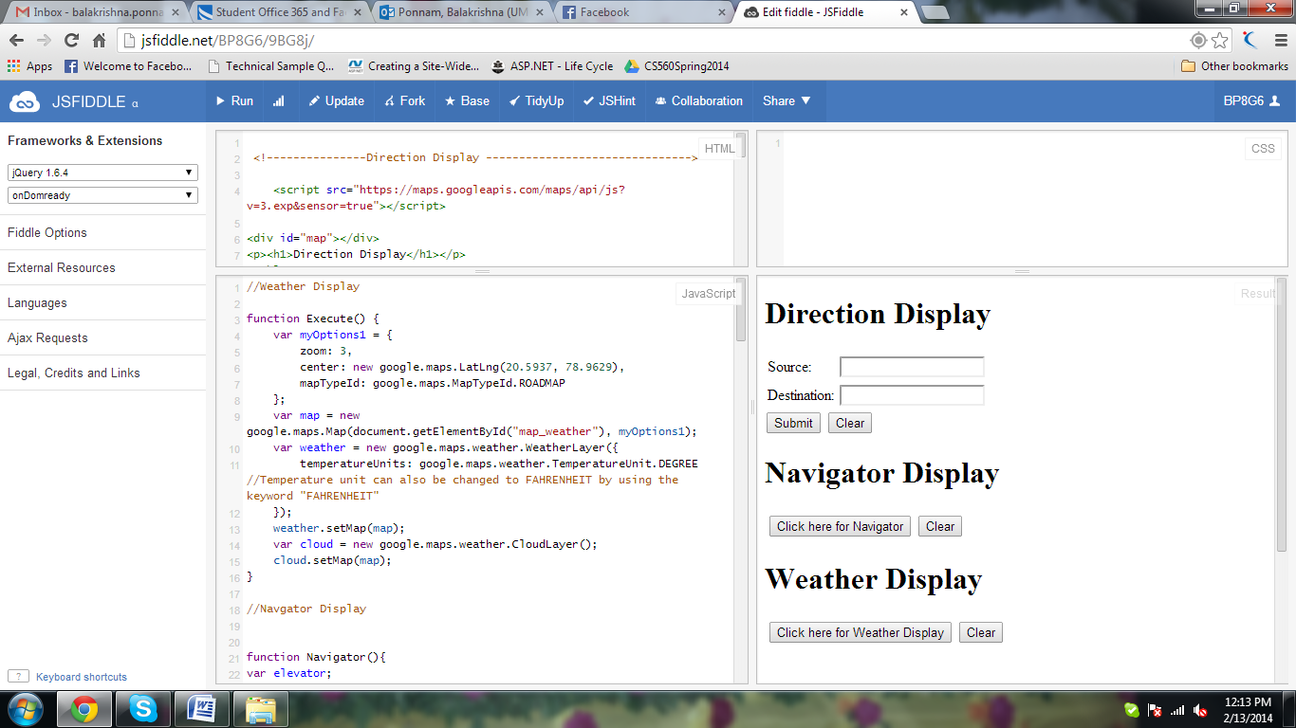

First Application is Direction Display.It gives the direction from source to the Destination.if we give the Source , Destination and press submit then the map shows the direction from source to destination.

The clear button is to clear the present path and can also find the new path by entering source,Destination and pressing the submit button.

We can also use zoom in and Zoom out option available in this service.And also both the Satelite View and the earth View.

The below scree shot shows the direction from New York to Kansas City.

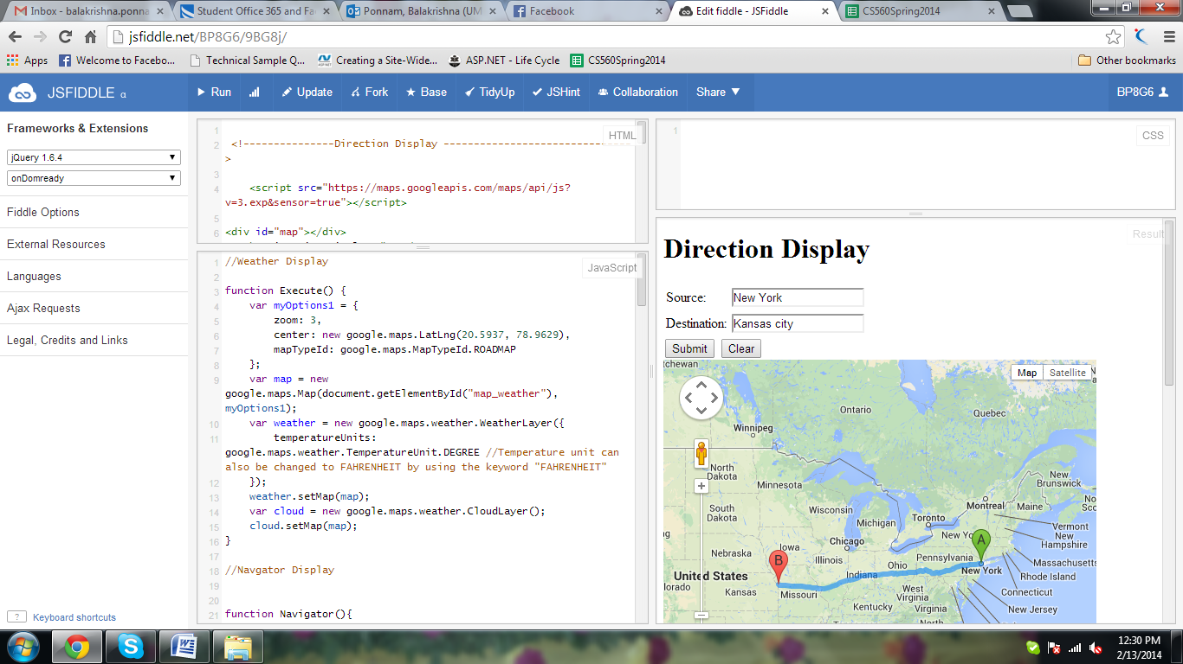

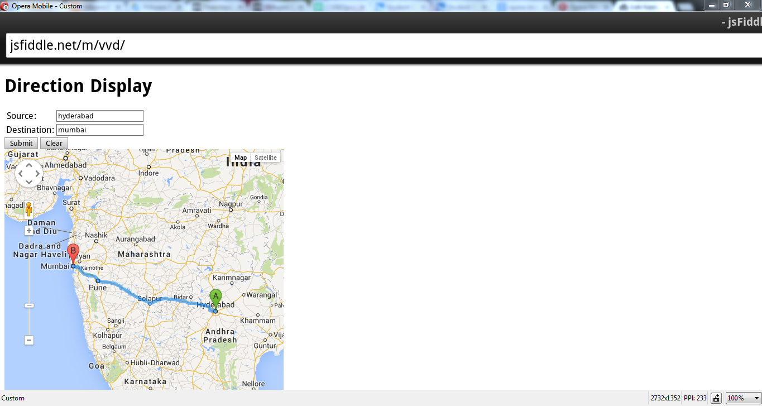

Another application used is Navigator Display.

By clicking on the button it displays our current location.And Clear button clears the previous Display.

The below screen shot shows the Navigator Display.

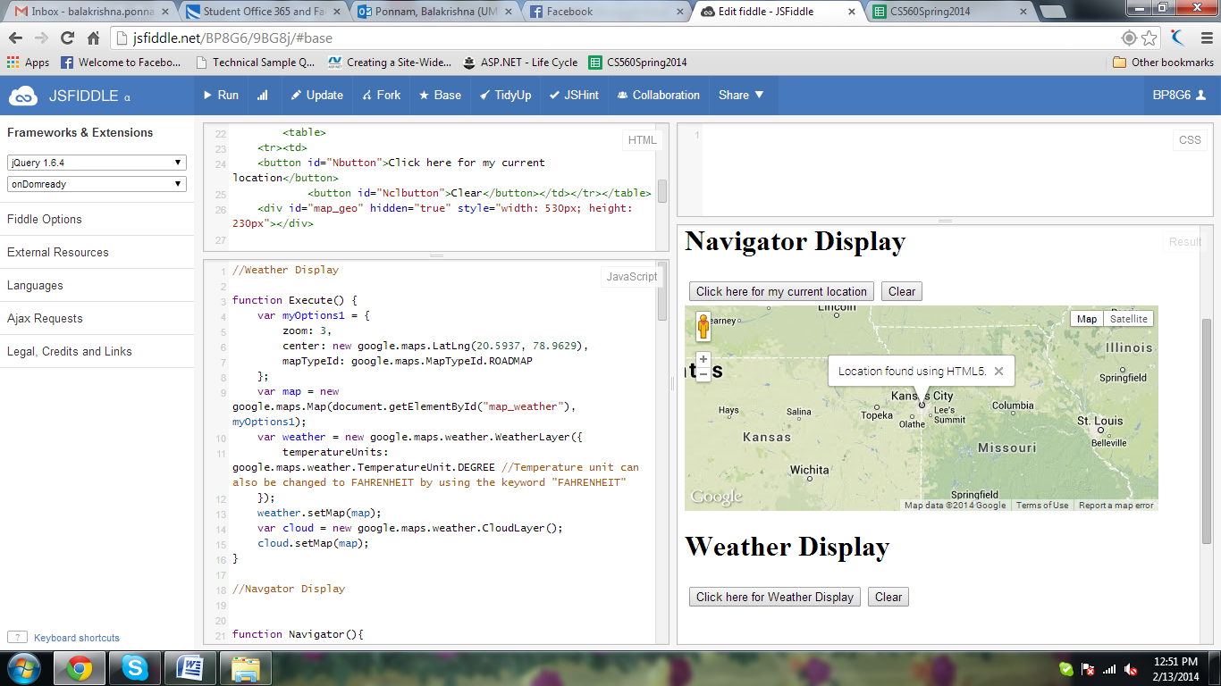

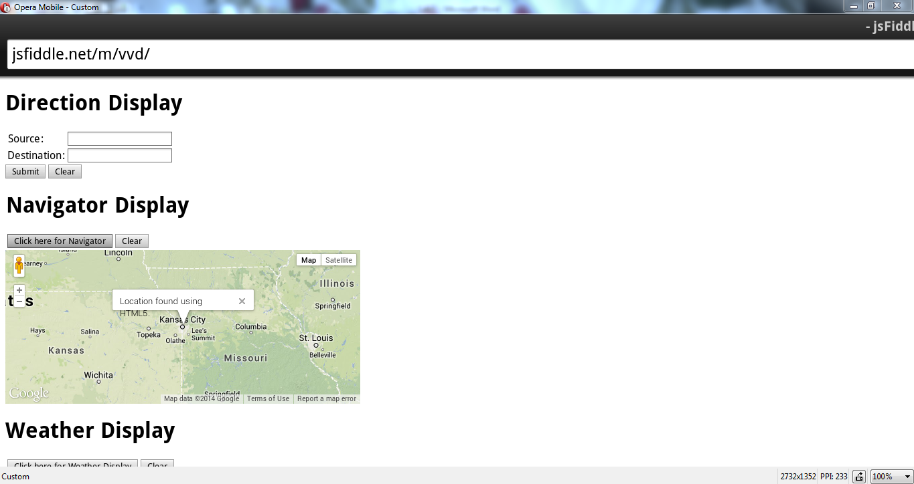

The next application done is Weather Display.

If we click on the Weather Display button it displays the weather of different places in our country.

If we click the clear button it clears the previous result.

The below screen describes the Weather of different places.

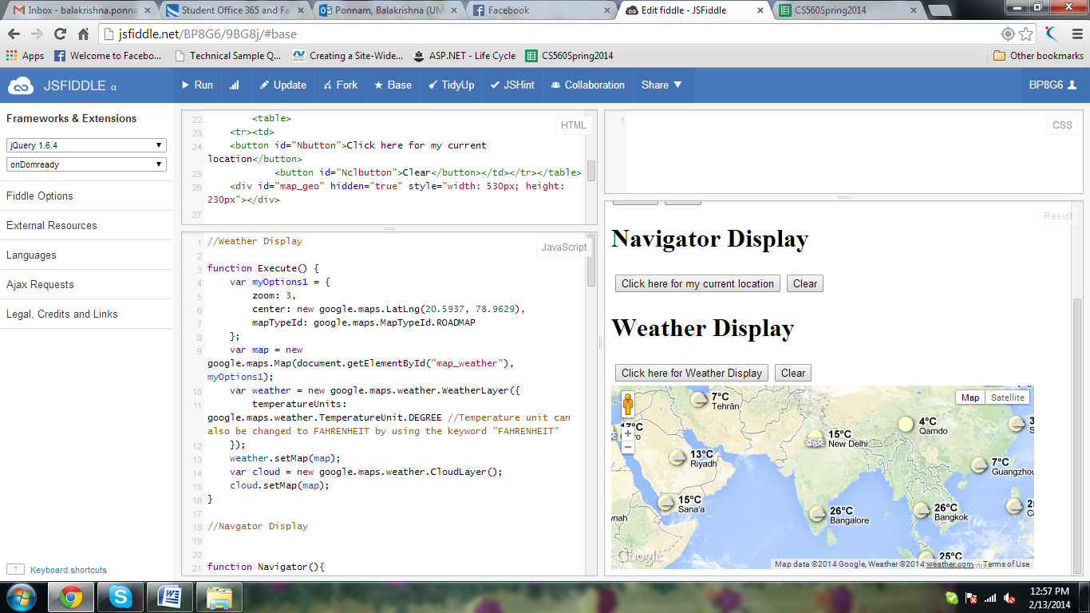

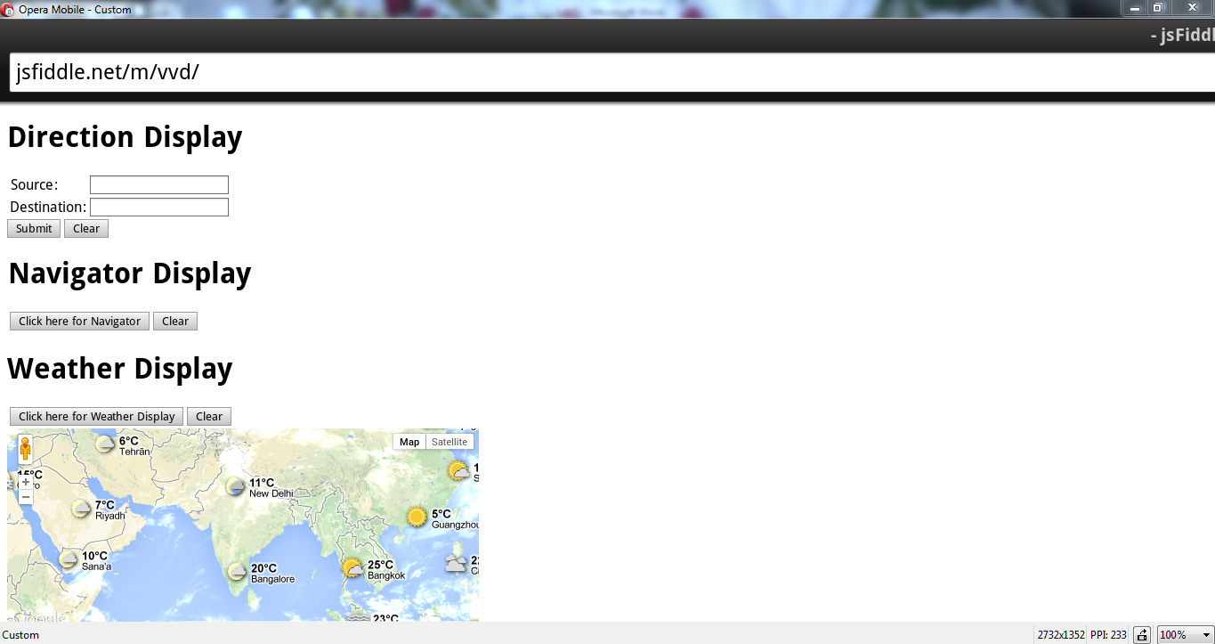

The below screen shot shows the application after clicking the clear button.it clears all the data and ready for the new search.

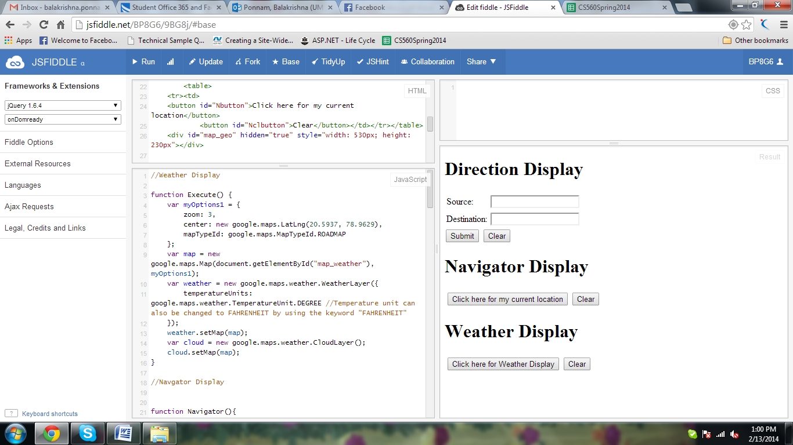

**2)Cloudera/Map Reduce**

To install Cloudera I have downloaded VM Player.

First Install VM Player and then download the cloudera image 4.5.It is downloaded in zip format.unzip it.

After installing VM Player goto File ---> Open open the image cloudera-quickstart-vm-4.4.0-1-vmware.

The below screen shot shows how to open the file.

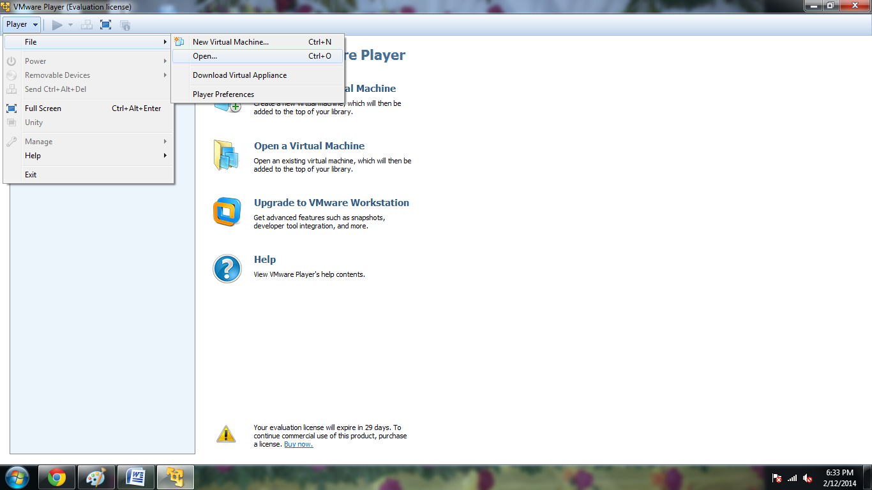

After opening the image cloudera will be installed and will boot to open the virstual machine.

The below screen shot shows the booting of virtual machine

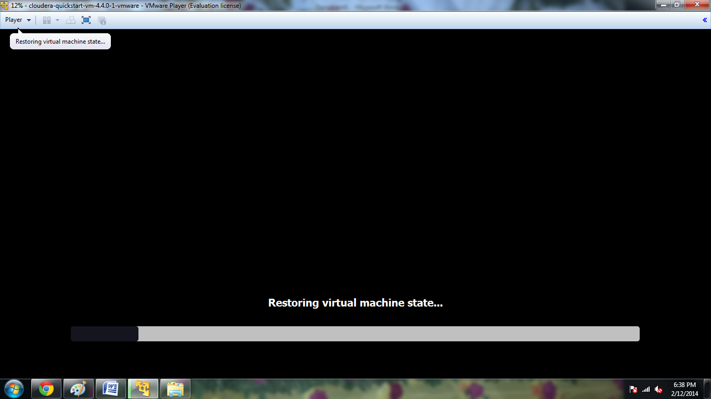

After booting is done it open the firefox browser with different tabs named as cloudera,cloudera manager,Hue,HDFS NameNode,etc….

It asks for the login.login with Username and Password as “Cloudera”.

The below screen shows the firefox browser with different tabs,logged screen and all the services.

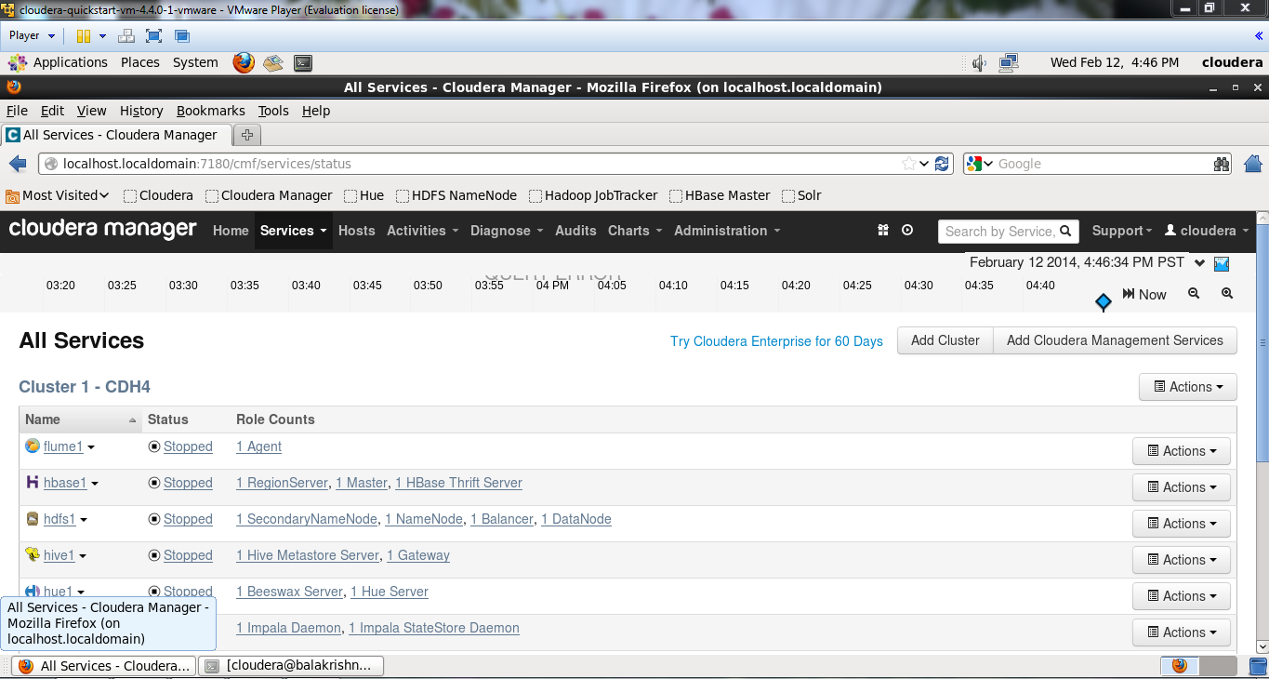

The below screen shot shows the upgradation of hosts.

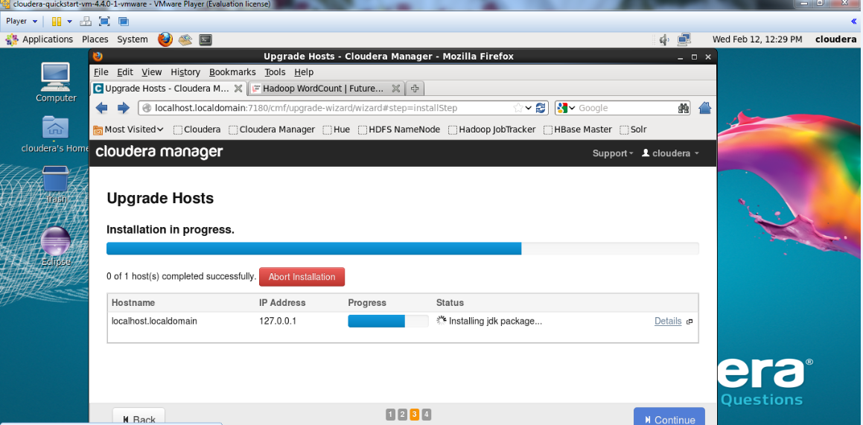

Now to execute word count example Download the source code of word count which is downloaded in Zip format.

Unzip the word Count File by running the command **Unzip WordCount.Zip in** the terminal.

Then put the local input file to the hadoop input directory using the command

**hadoop fs –put input input.**

Next run the hadoop using the command **hadoop** **jar wordcount.jar WordCount input output**.

To see the result from output run the command **hadoop fs –cat output/\***

The below screen shows the result from output.

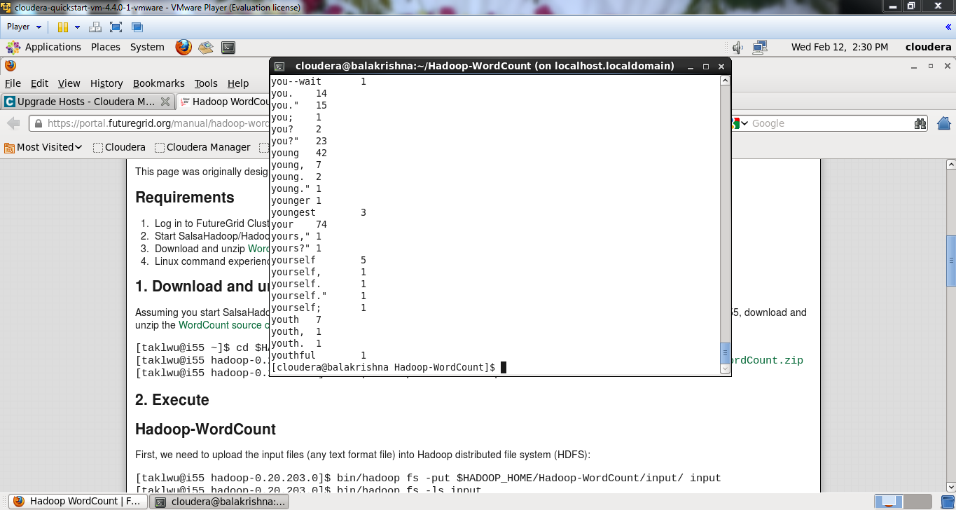

The above word Count example reads all the sentences in the text file and gives the result as number of words used in the total document.

It shows the each word used number of times in the coulomb.

The above screen shot shows the Word and count of the words used in the text document.

**3) Cloudera/Mahout:**

To Install Mahout

Download **Maven** using the command “**wget”** before download link**.** it will download the tar file

Extract the folder using the command “**tar –zxvf apache-maven-3.0.5-bin.tar.gz”.**

Set the environment variable path and then install Maven.

To see the Maven version run the command “**mvn –version**”.

The below screen shows the maven version.

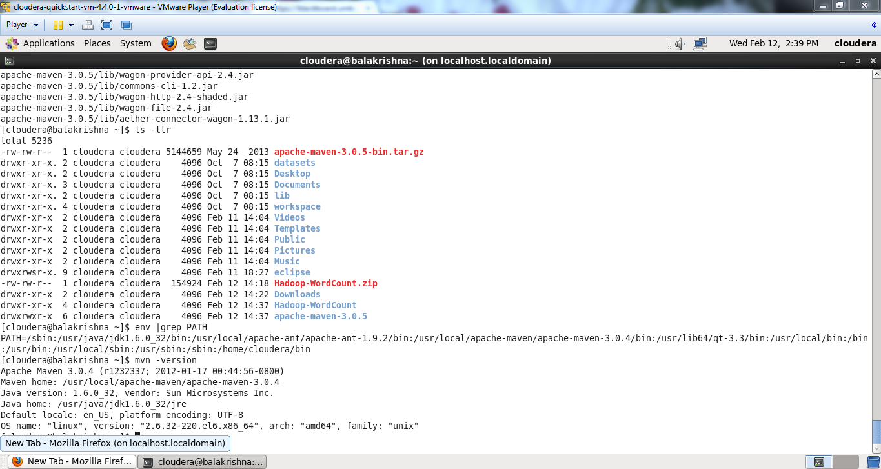

Next Install Mahout

Download the files **mahout-distribution-0.6.pom** and **mahout-distribution-0.6.zip**

Unzip the zip file and copy the pom file in mahout-distribution-0.6

Then to install Mahout using pom by maven run the command

**mvn –f mahout-distribution-0.6.pom -DskipTestsinstall**

This screen shot shows the download of mahout-distibution-0.6.zip

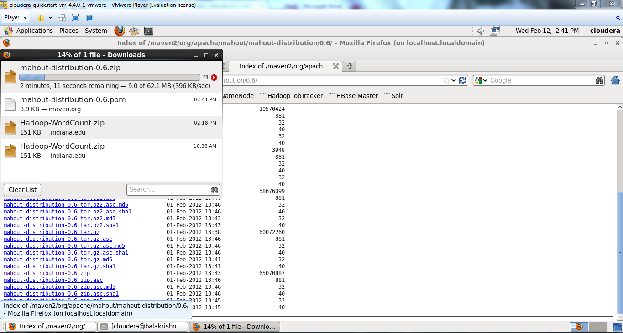

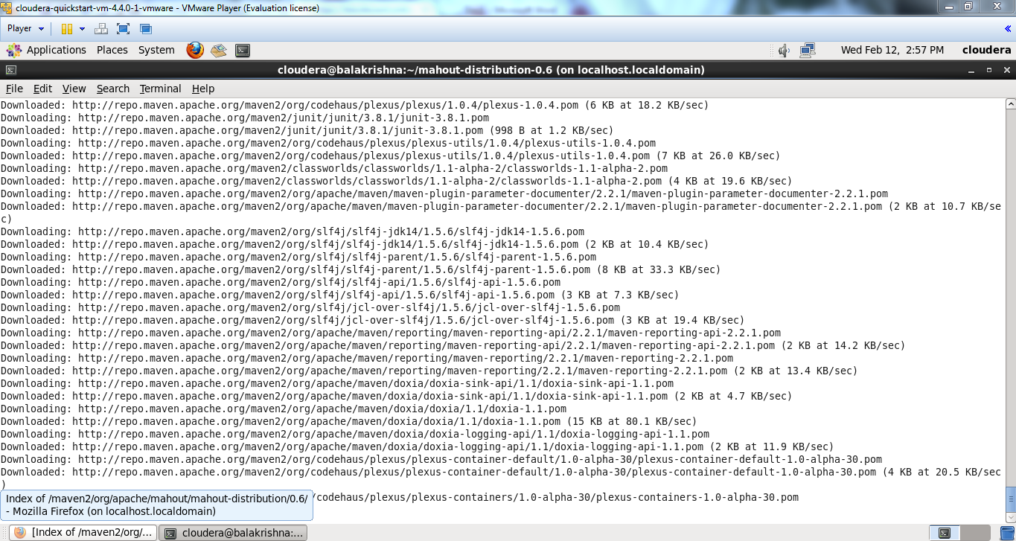

The below screen shot shows the unzip of Mahout distribution file.

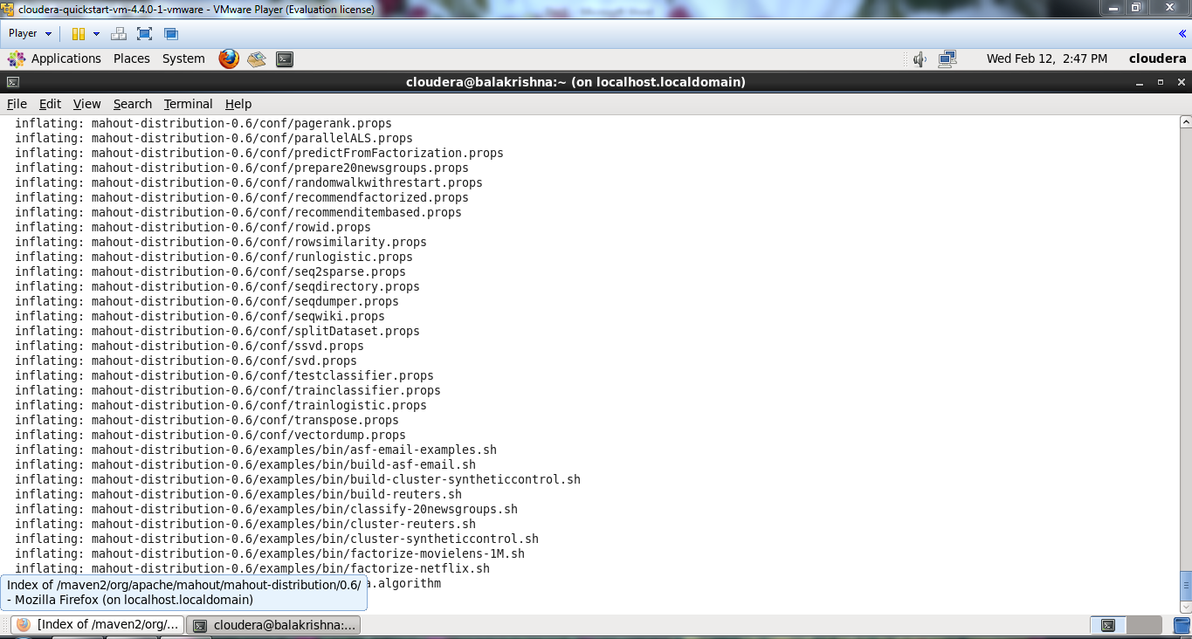

The below screen shows the Successful installation of mahout.

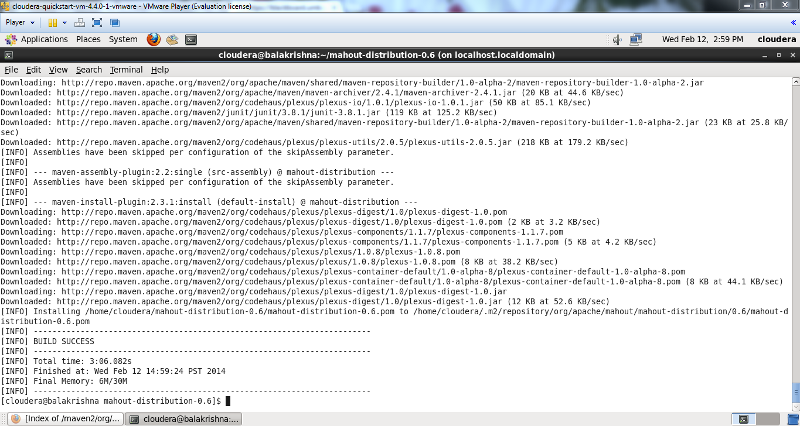

The below screen shows the execution of Naïve Bayes Classifier with the input data.

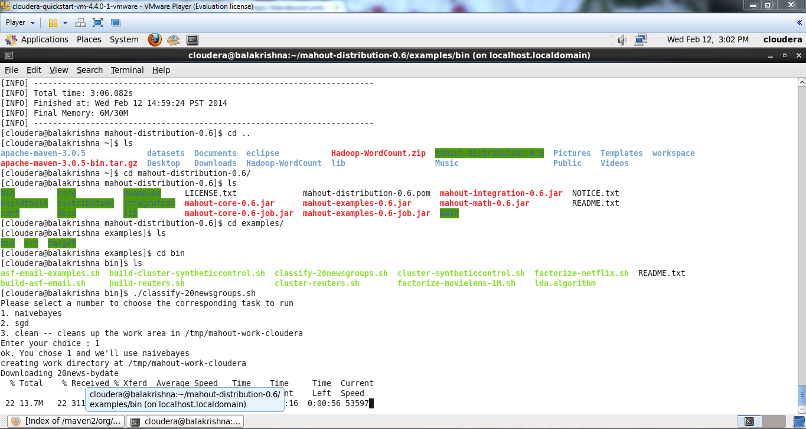

The below screen shows the result of the NavieBayes Classifier with the input data.

